DEALS TO DAYTONA

Daytona: not just for NASCAR fans and Spring Breakers. Although it’s home to the Daytona International Speedway, this city offers many other fabulous things to do all year round. Check out these Daytona activities when you visit. Book a trip to Daytona via Orlando International Airport on Virgin America. Live it up at 35,000 feet with WiFi, on-demand entertainment, and more on every flight.

(MARKET IMAGE HERE)

Find Deals From These Cities

INSERT FARE GRID FROM / TO Version (if available!)



Top Things To Do in Daytona

. Check out these Daytona activities when you visit.

* Relax in the sun at the “World’s Most Famous Beach”. Drawing large crowds, Daytona Beach is known for its firm sand (which allows cars to be parked right on the beach!) and busy pier. After taking in some rays, walk along the mile-long, pedestrian-only zone surrounding the pier.
* Take a break from the sun and explore the artsy side of Daytona at the Art League of Daytona Beach and Southeast Museum of Photography.
* Climb to the top of the tallest lighthouse in Florida, Ponce de Leon Inlet Lighthouse & Museum, which was designated a National Historic Landmark in 1988. Just be sure to bring comfortable shoes - the climb is a long one, but the views are a perfect reward!
* Get behind the wheel at the Daytona International Speedway. When you sign up for the Richard Petty Driving Experience, you’ll get to speed around the 2½-mile-long speedway. Not that daring? You can always ride as a passenger with an instructor - but you’ll still need to be prepared to experience crazy fast speeds.

Travel Tips and Resources

[Must-Dos in Daytona](http://www.daytonabeach.com/things-to-do/top-10)

[Daytona Hotels](http://www.tripadvisor.com/Hotels-g34172-Daytona_Beach_Florida-Hotels.html)

[Daytona Restaurants](http://www.tripadvisor.com/Restaurants-g34172-Daytona_Beach_Florida.html)

[Daytona Shopping Guide](http://www.daytonabeach.com/things-to-do/shopping)

[Daytona Nightlife and Entertainmenthttp://www.daytonabeach.com/things-to-do/nightlife](http://www.daytonabeach.com/things-to-do/nightlife)

[Daytona Travel Tips](http://www.fodors.com/world/north-america/usa/florida/northeast-coast/places/daytona-beach)

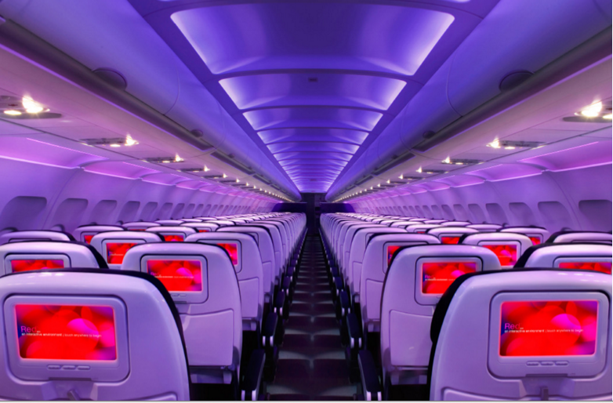

Main Cabin Main Cabin Select First Class

(add links to Cabin Class Pages)

Ready. Set. Fly.

Book your Mood-lit Ride to Daytona.

Visiting Daytona? Book a flight to Orlando International Airport with Virgin America and rent a car for the less than 90-minute drive to Daytona. When you fly with us, you’ll experience a truly relaxing flight. Take a virtual tour to see all of the distinct amenities you’ll enjoy on our flights, including on-demand food ordering, in-flight WiFi, and mood-lit cabins.

Take a Virtual Tour

Add Terms & Conditions